Higher Order Function

**Higher Order Function**

A higher order function is a function that does at least one of the following

* ** Takes one or more function as an argument (Parameter)
* ** Return a function as the result

Higher order functions are functions that take one or more functions as arguments, or return a function as their result.

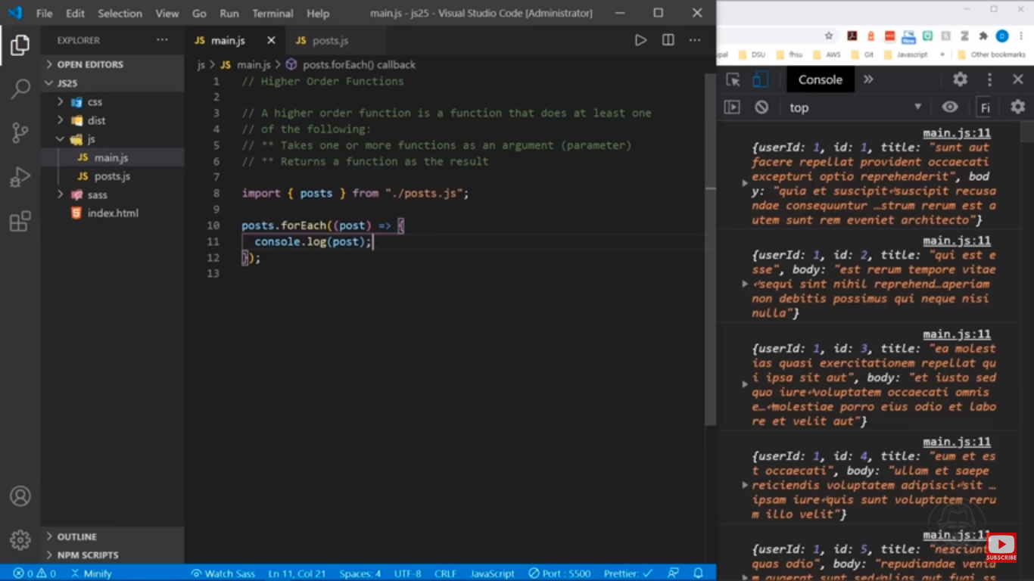

filter() function

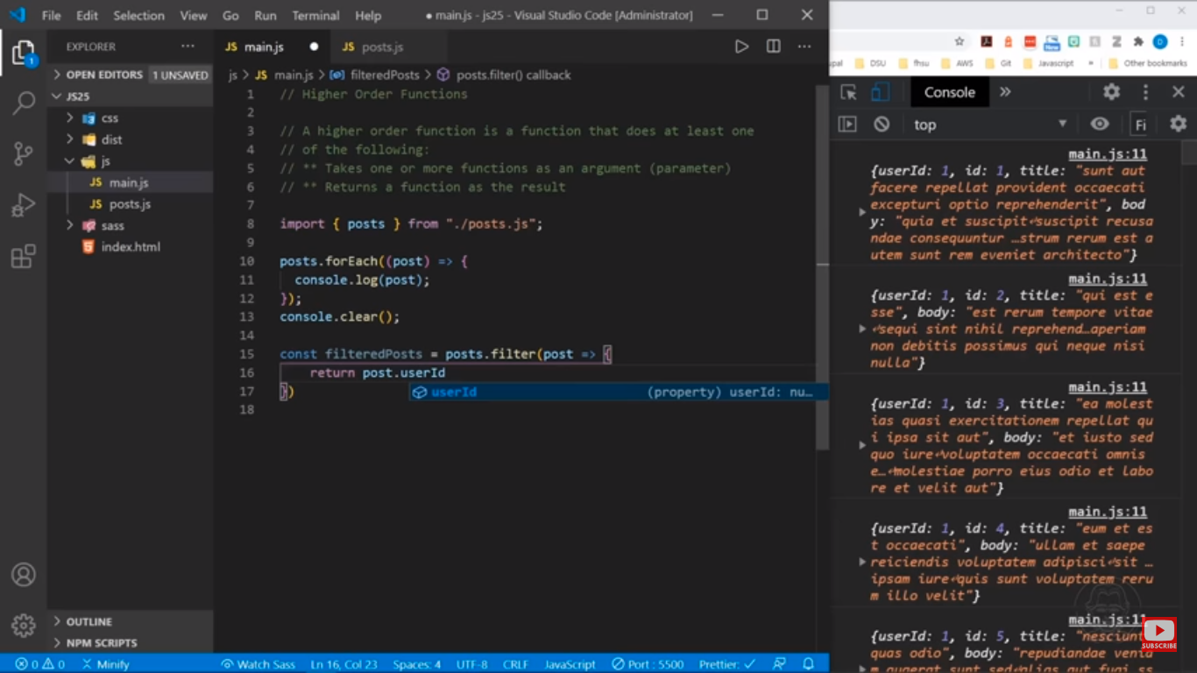

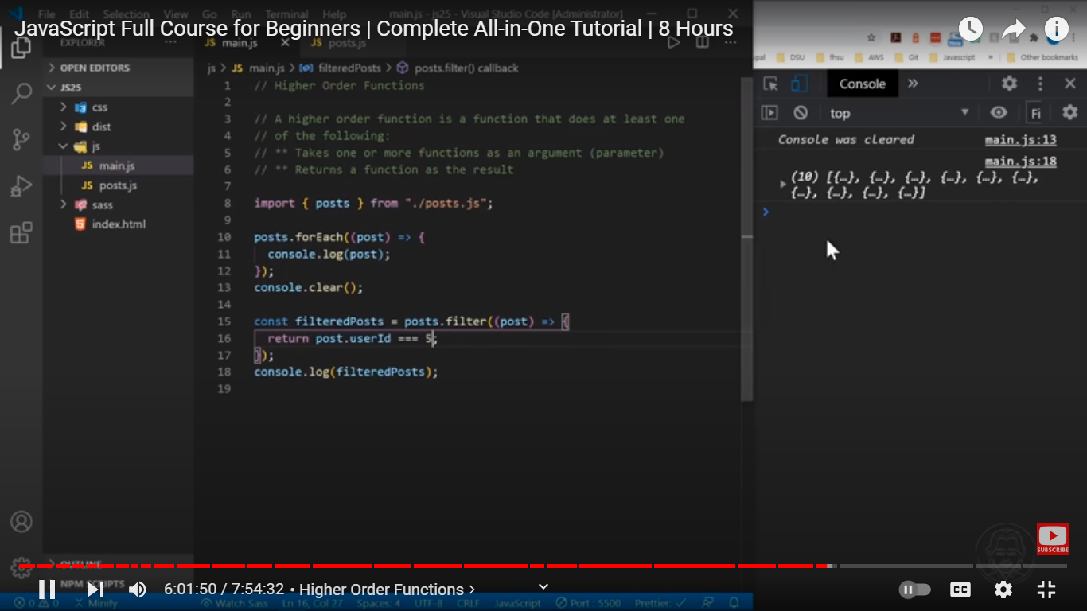

map() function

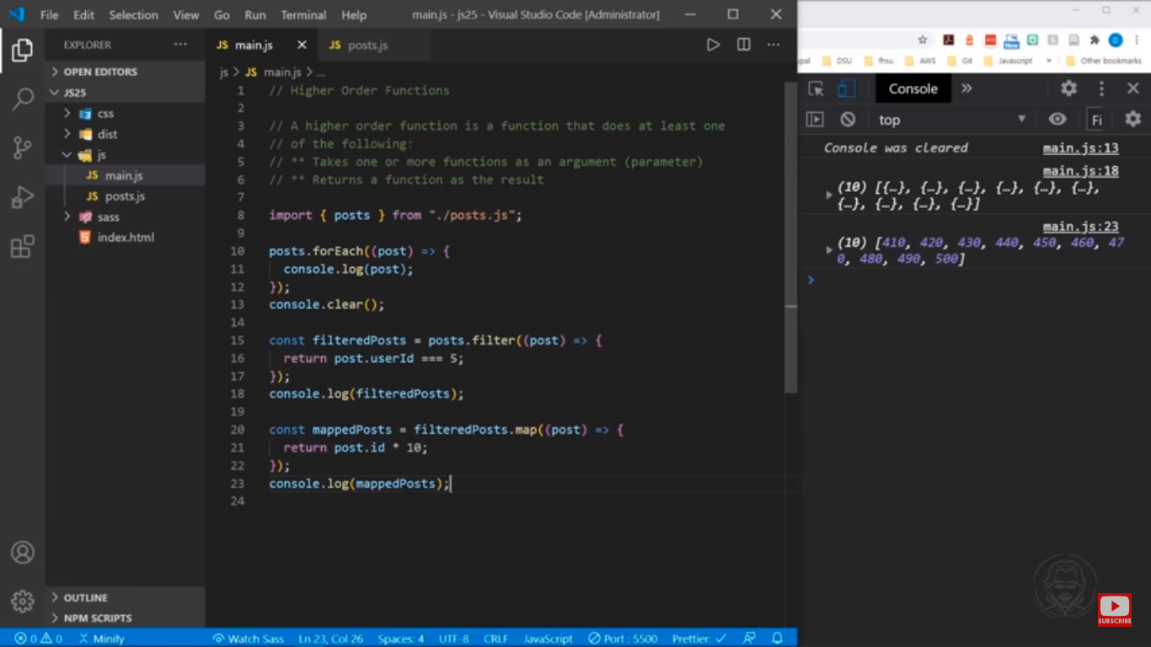

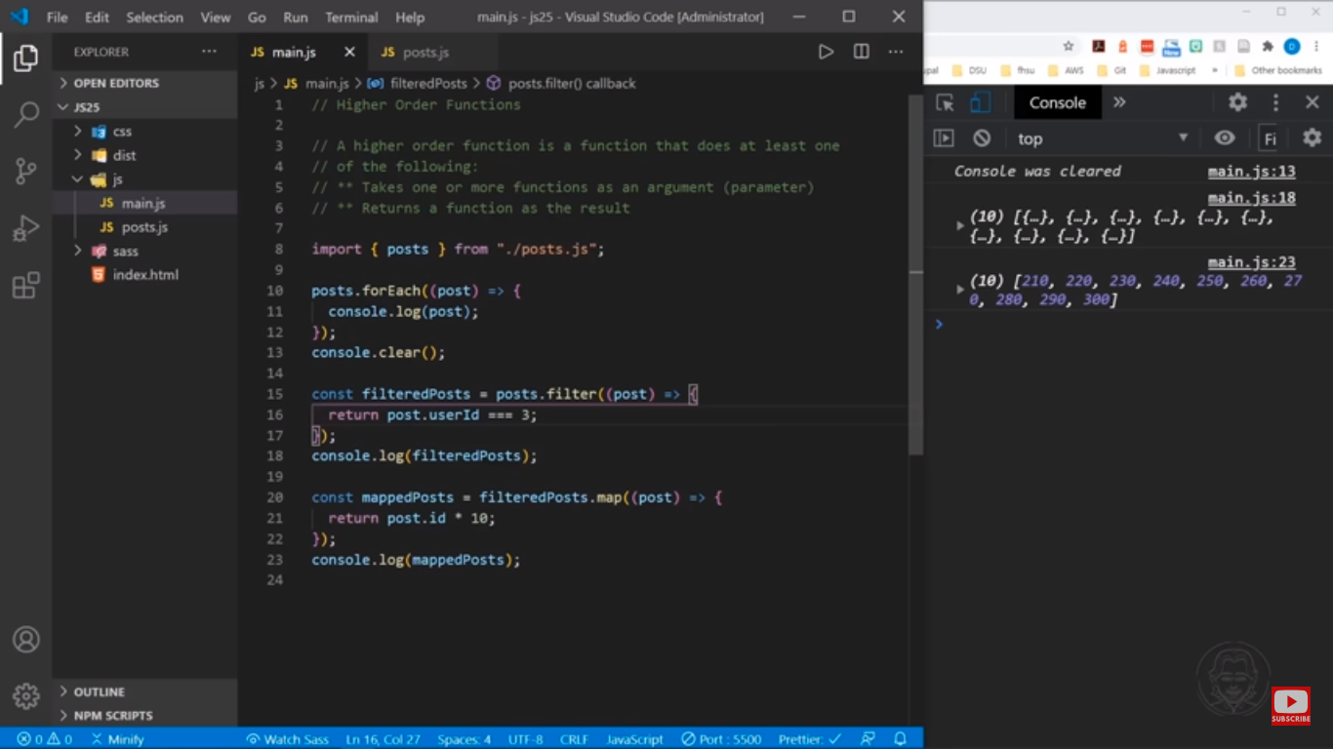

reduce() function

